CMPE 315: Principles of VLSI Design
Lab Cover Page

Lab # : 4
Lab Title : D Flip-flop layout and simulations

Name : Nem Negash
Section : 1

Date Submitted : 10/15/2021

TA / Grader Use Only:

Late Submission Deduction (20% per day late):

Other Deductions:

Final Lab Grade:

Comments to student:

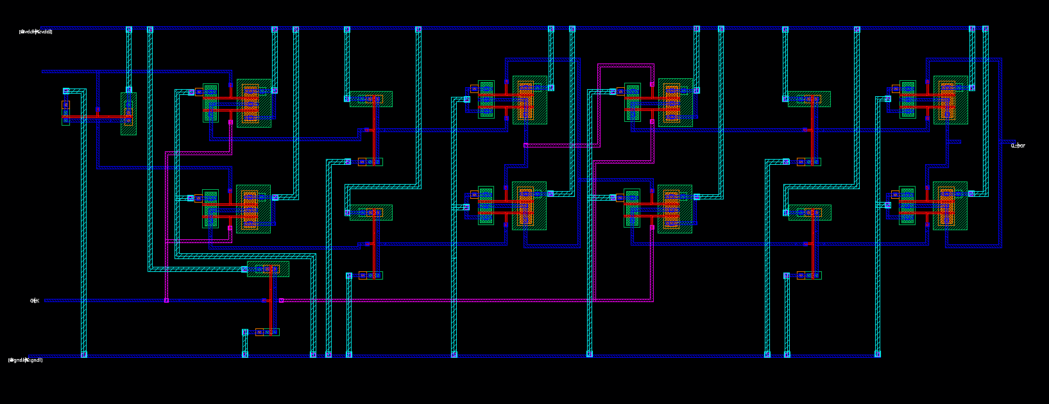
Figure 1: Logic gate D Flip-Flop Layout

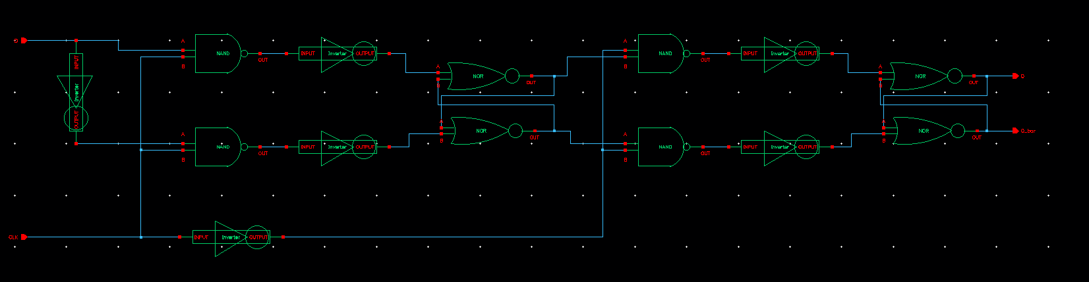
Figure 2: Logic gate D Flip-Flop Schematic

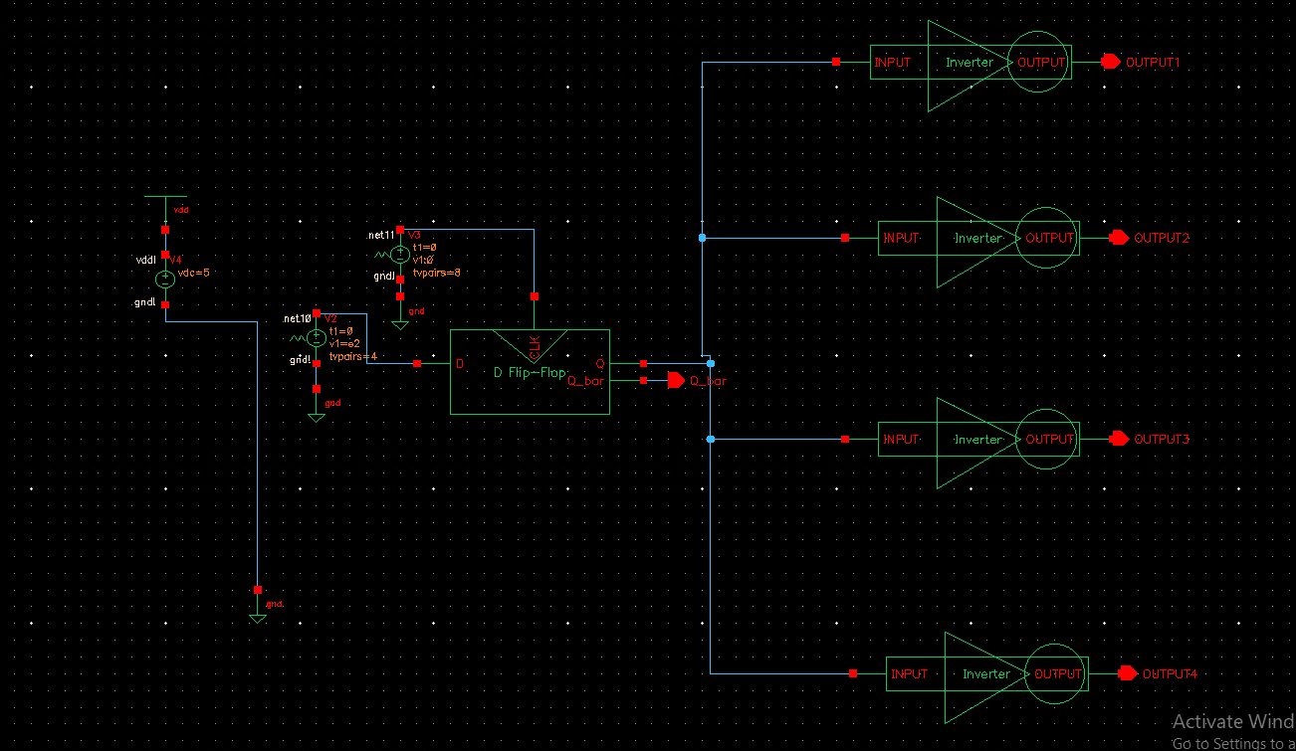
Figure 3: Logic gate D Flip-Flop Simulation Schematic
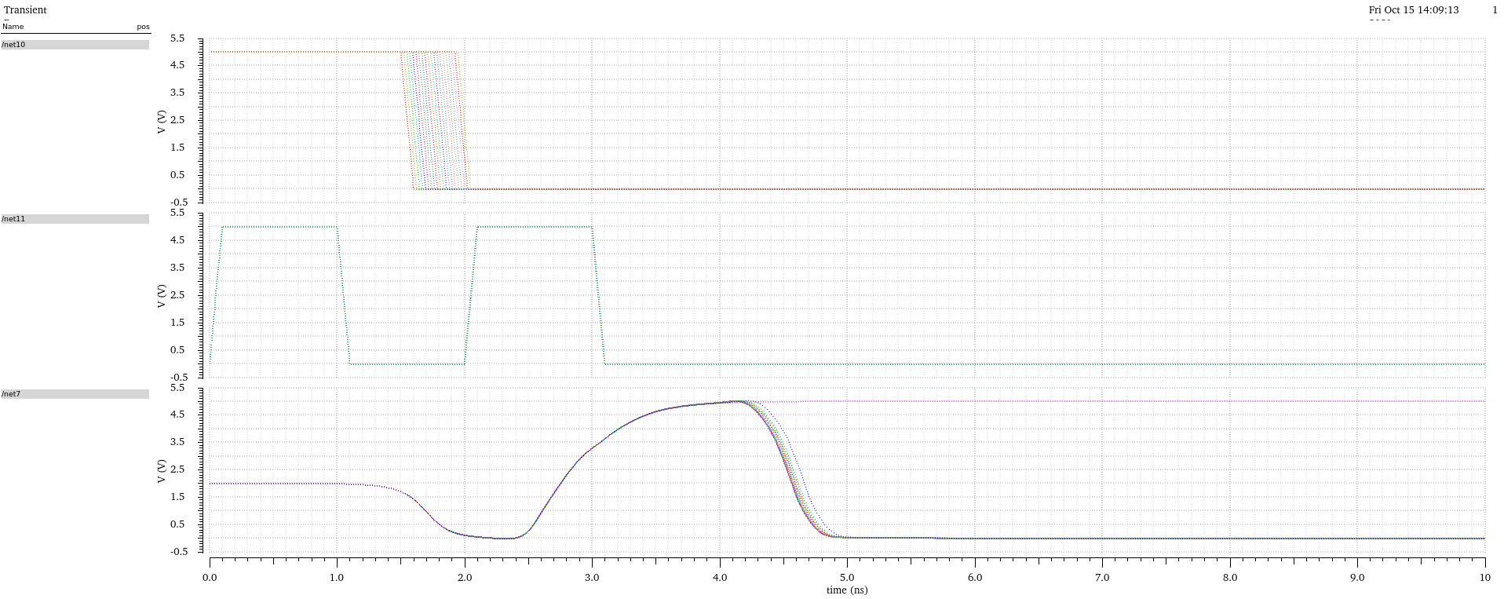
Figure 4: Extracted Logic Gate Flip Flop Coarse Sweep Latching 0
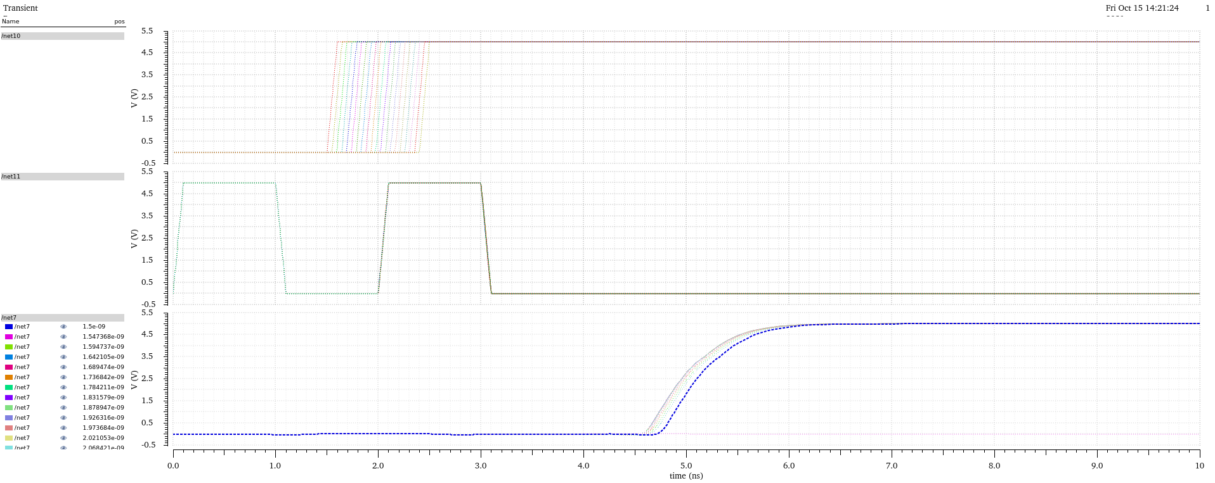
Figure 5: Extracted Logic Gate Flip Flop Coarse Sweep Latching 1
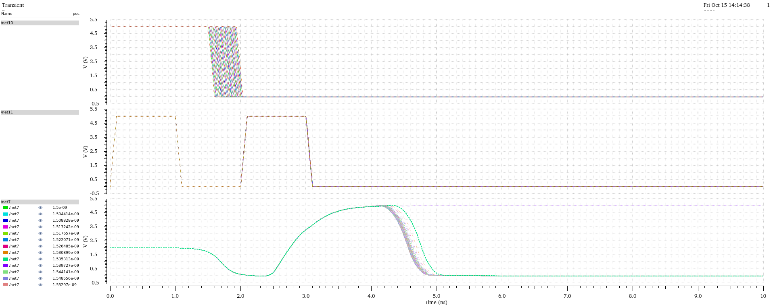
Figure 6: Extracted Logic Gate Flip Flop Fine Sweep Latching 0

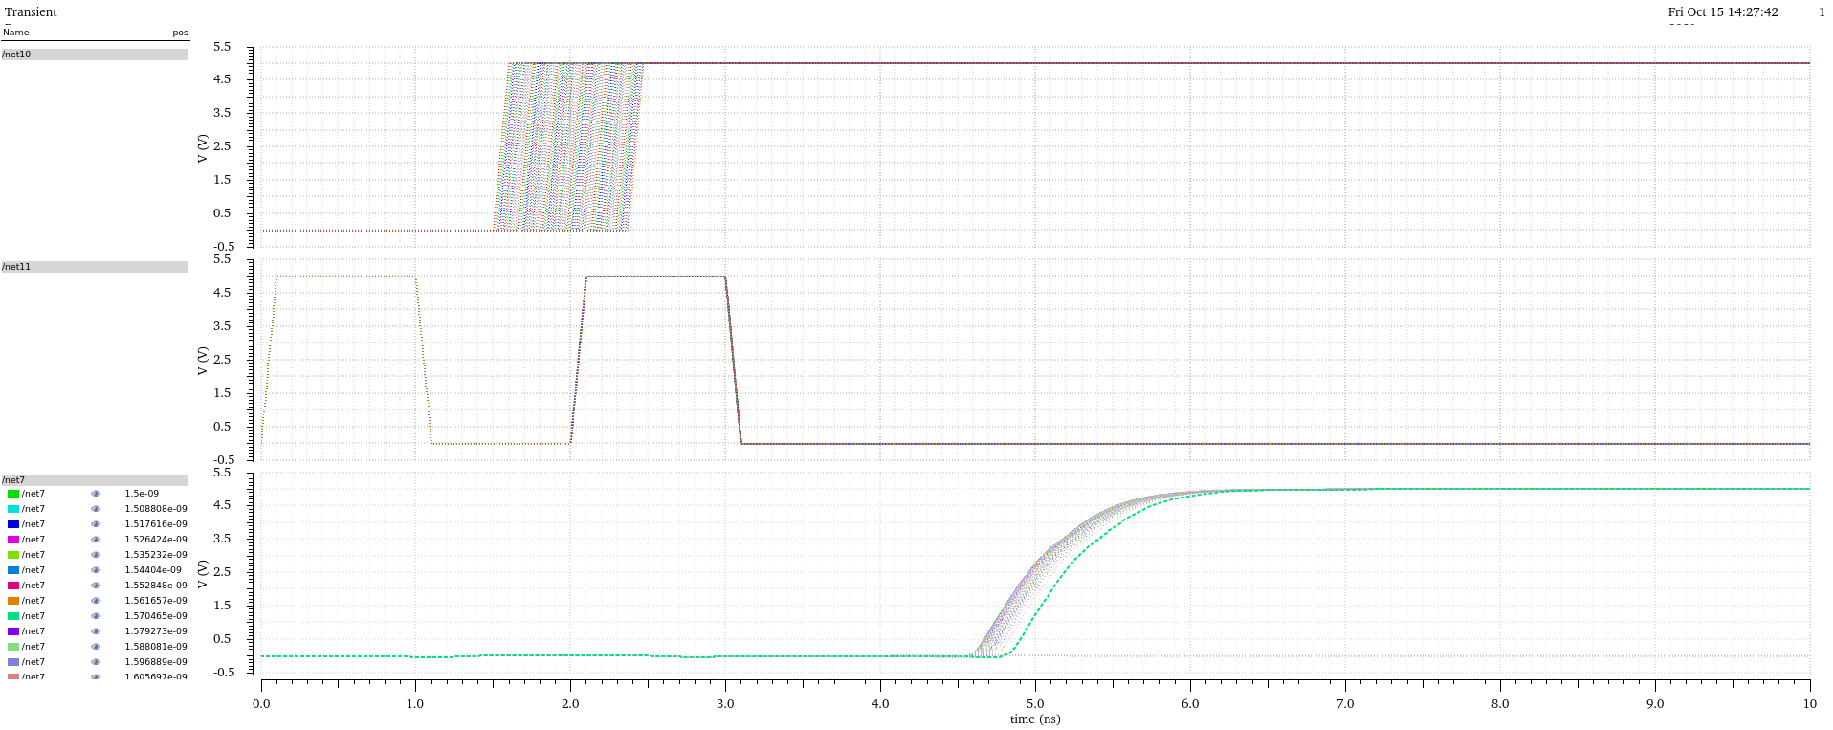
Figure 7: Extracted Logic Gate Flip Flop Fine Sweep Latching 1
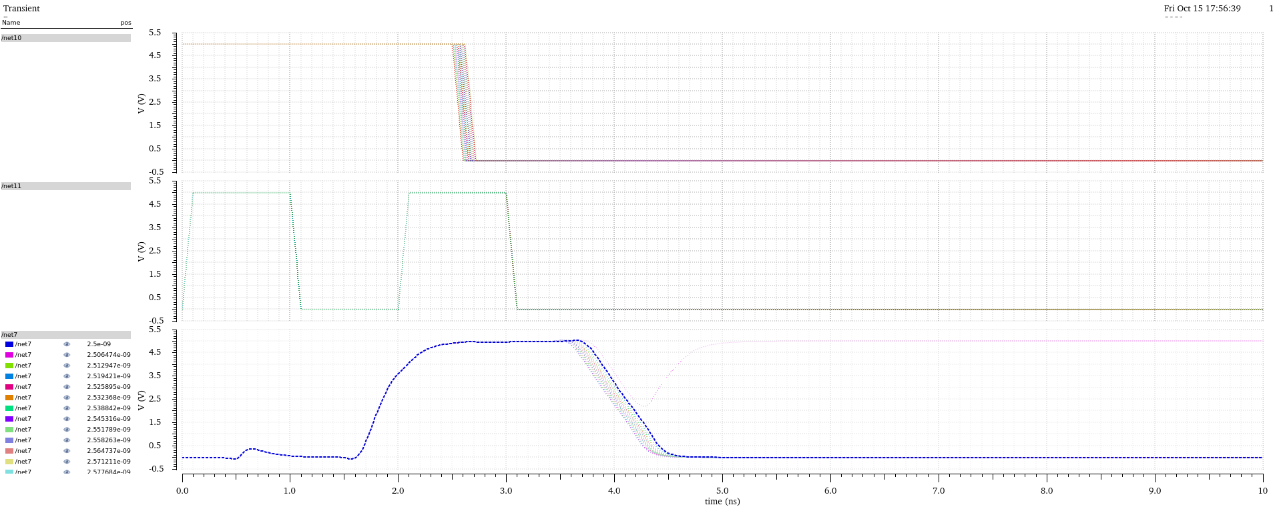
Figure 8: Schematic Logic Gate Flip Flop Coarse Sweep Latching 0
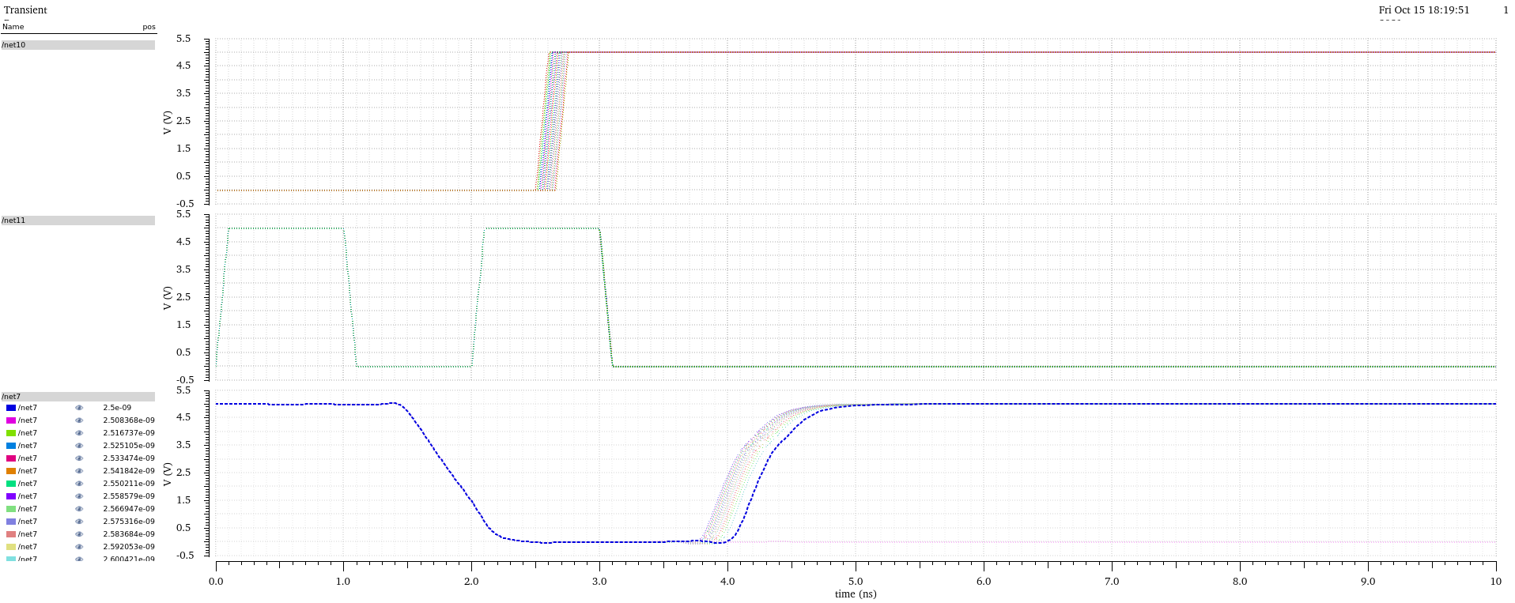
Figure 9: Schematic Logic Gate Flip Flop Coarse Sweep Latching 1
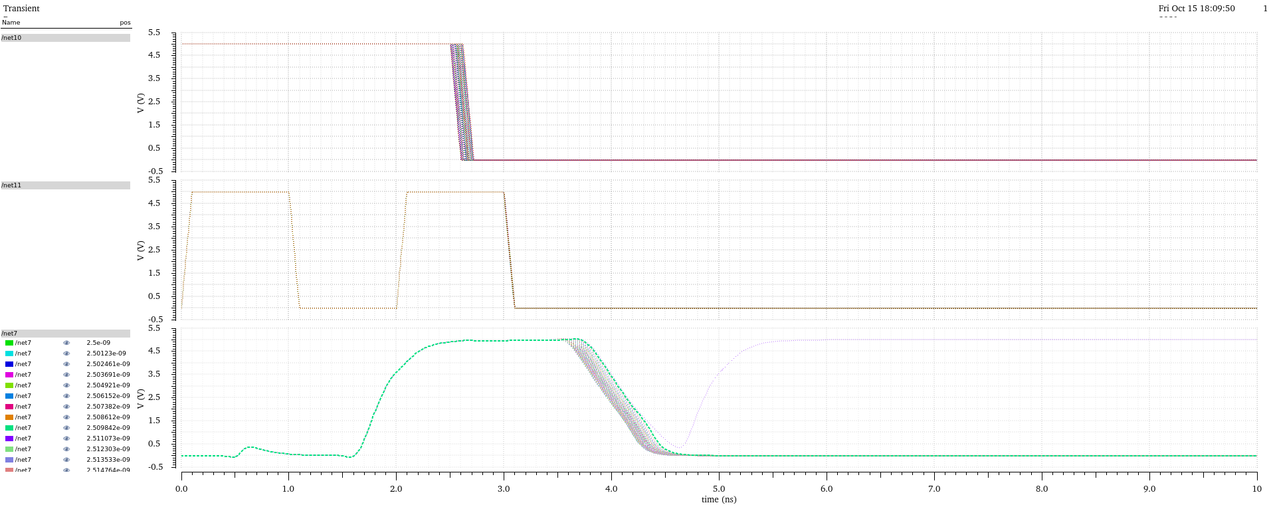
Figure 10: Schematic Logic Gate Flip Flop Fine Sweep Latching 0
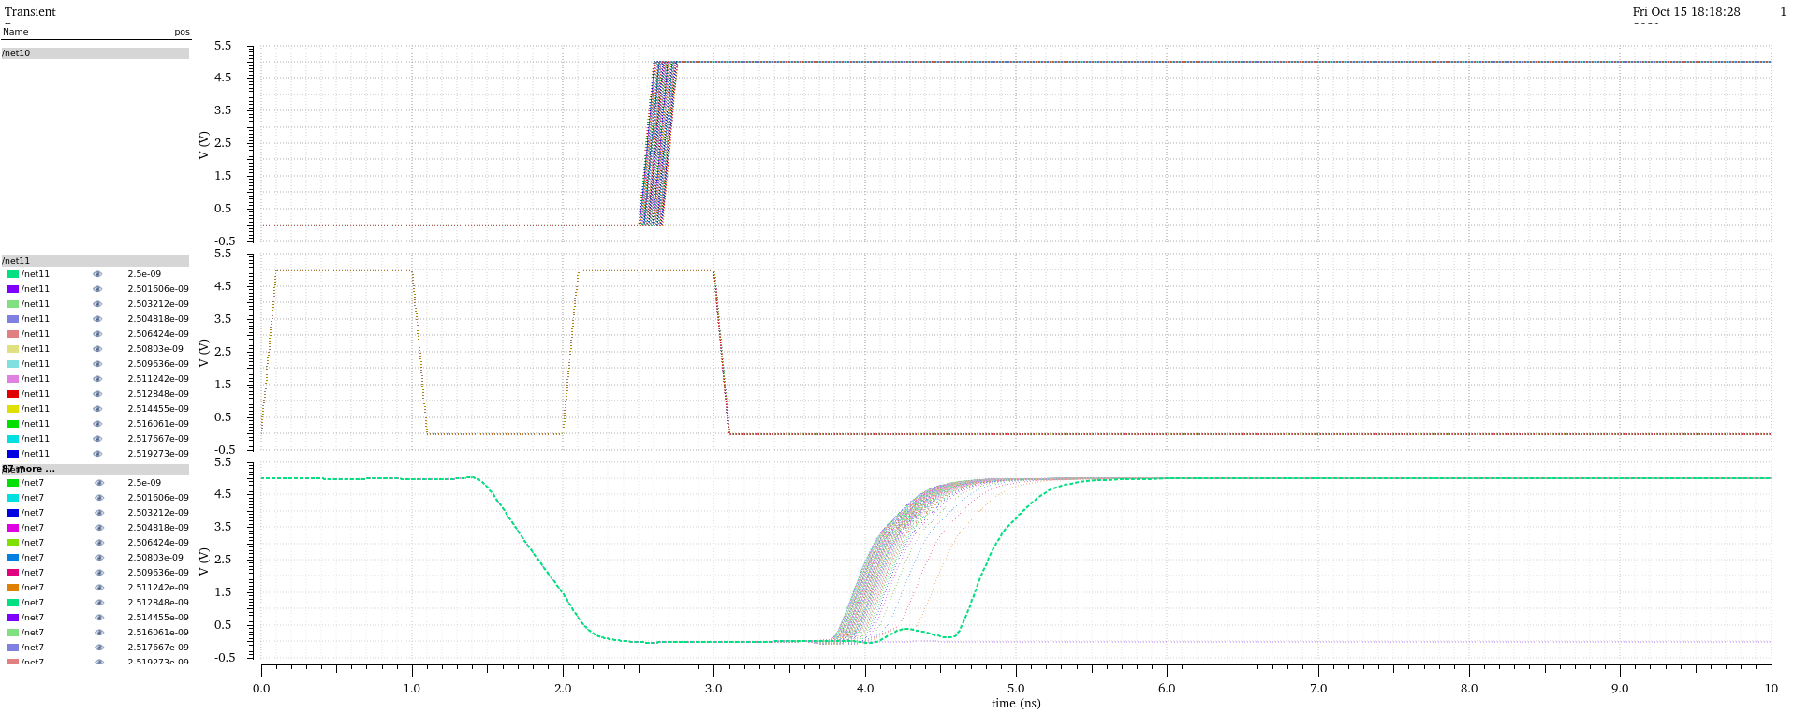
Figure 11: Schematic Logic Gate Flip Flop Fine Sweep Latching 1

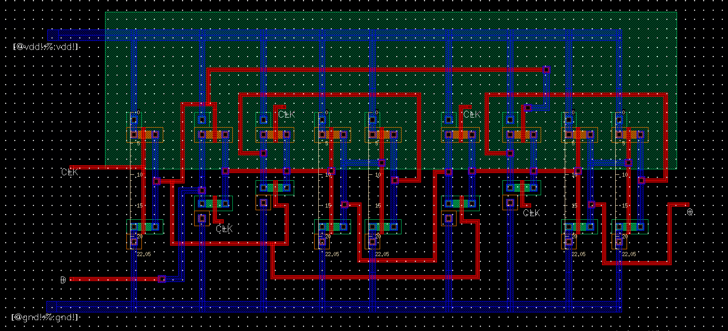
Figure 12: Transmission Gate D Flip-Flop Layout

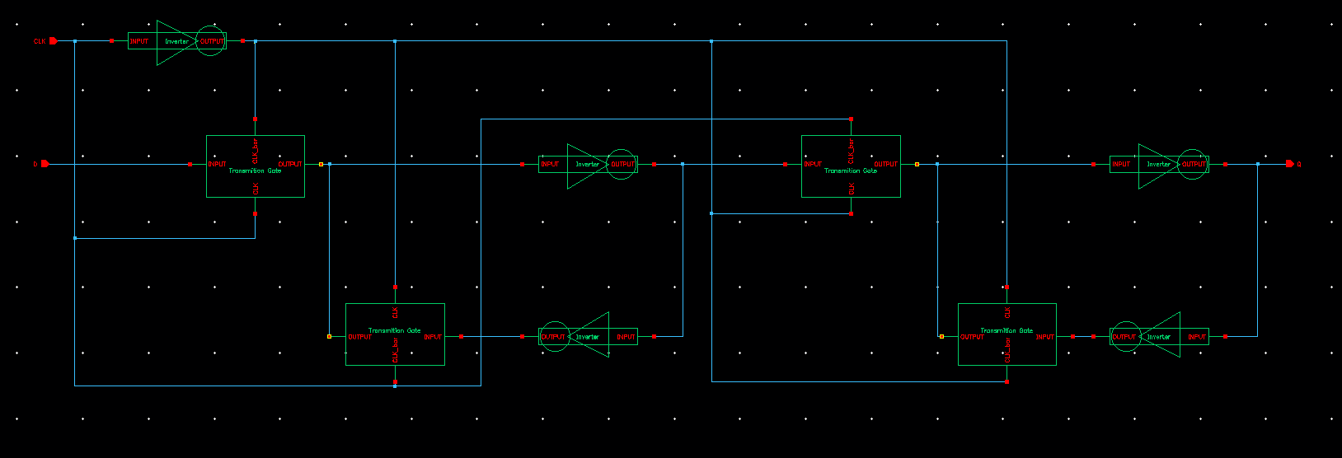
Figure 13: Transmission Gate D Flip-Flop Schematic

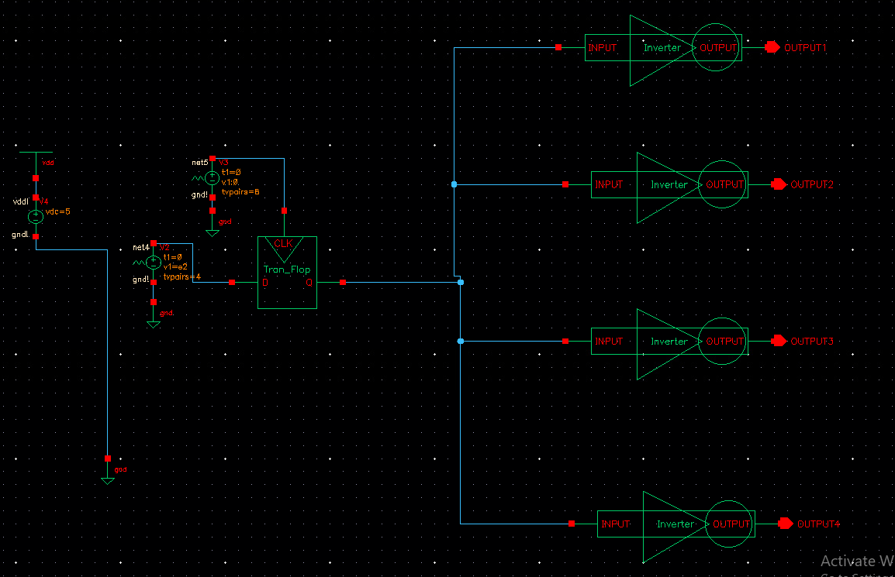
Figure 14: Transmission Gate D Flip-Flop Simulation Schematic
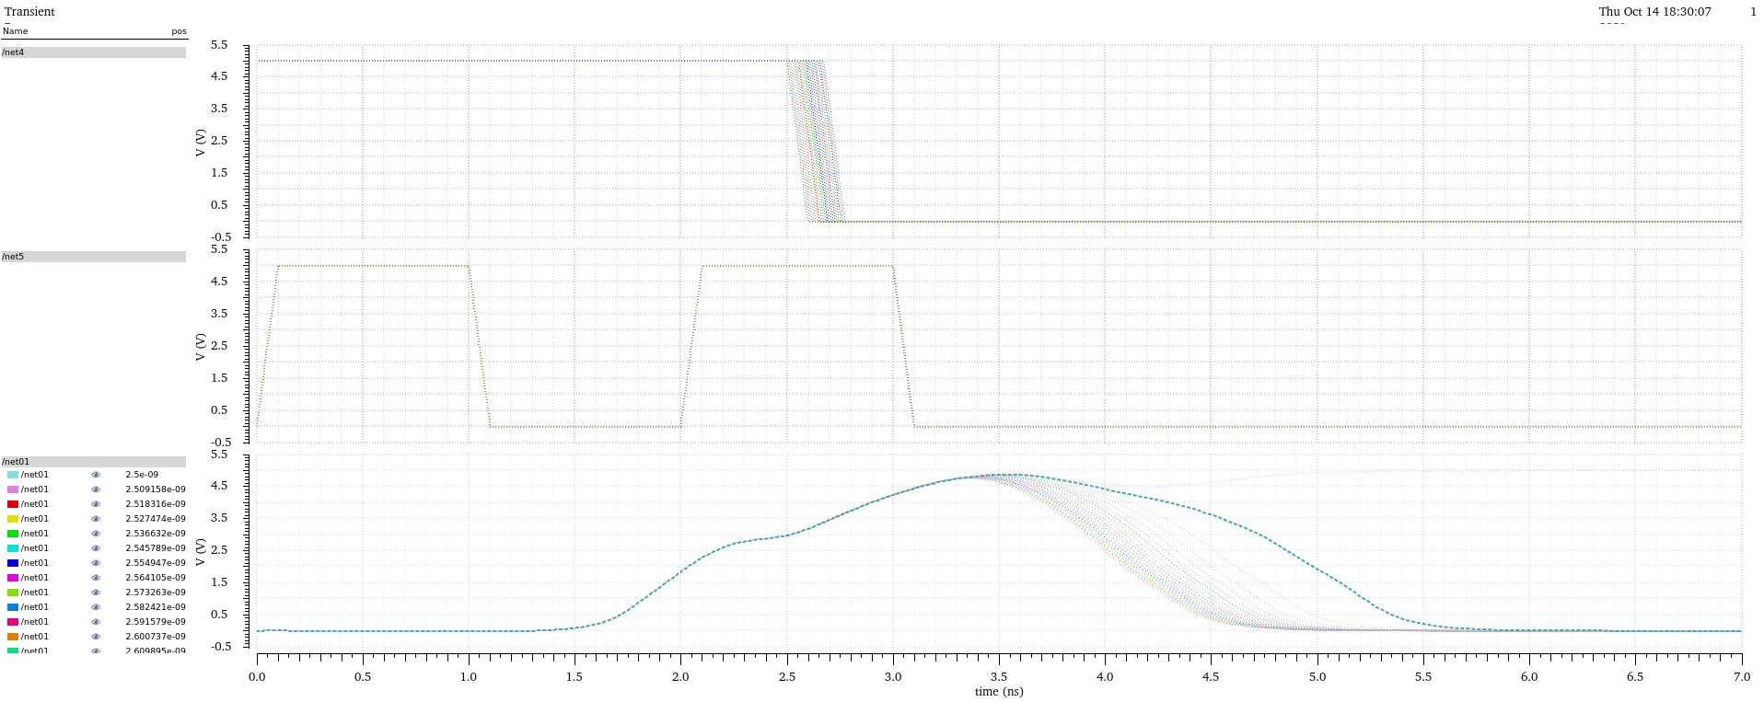
Figure 15: Extracted Transmission Gate Flip Flop Coarse Sweep Latching 0
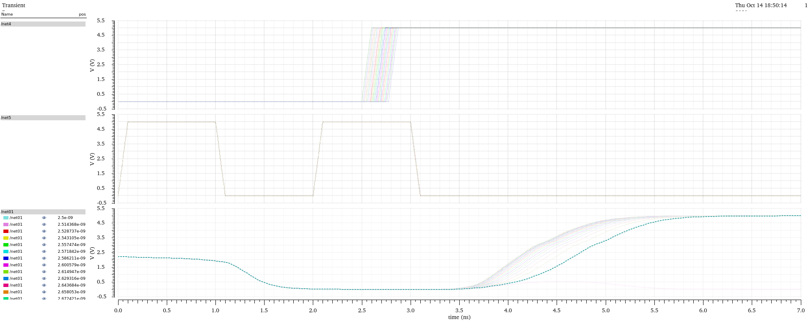
Figure 16: Extracted Transmission Gate Flip Flop Coarse Sweep Latching 1
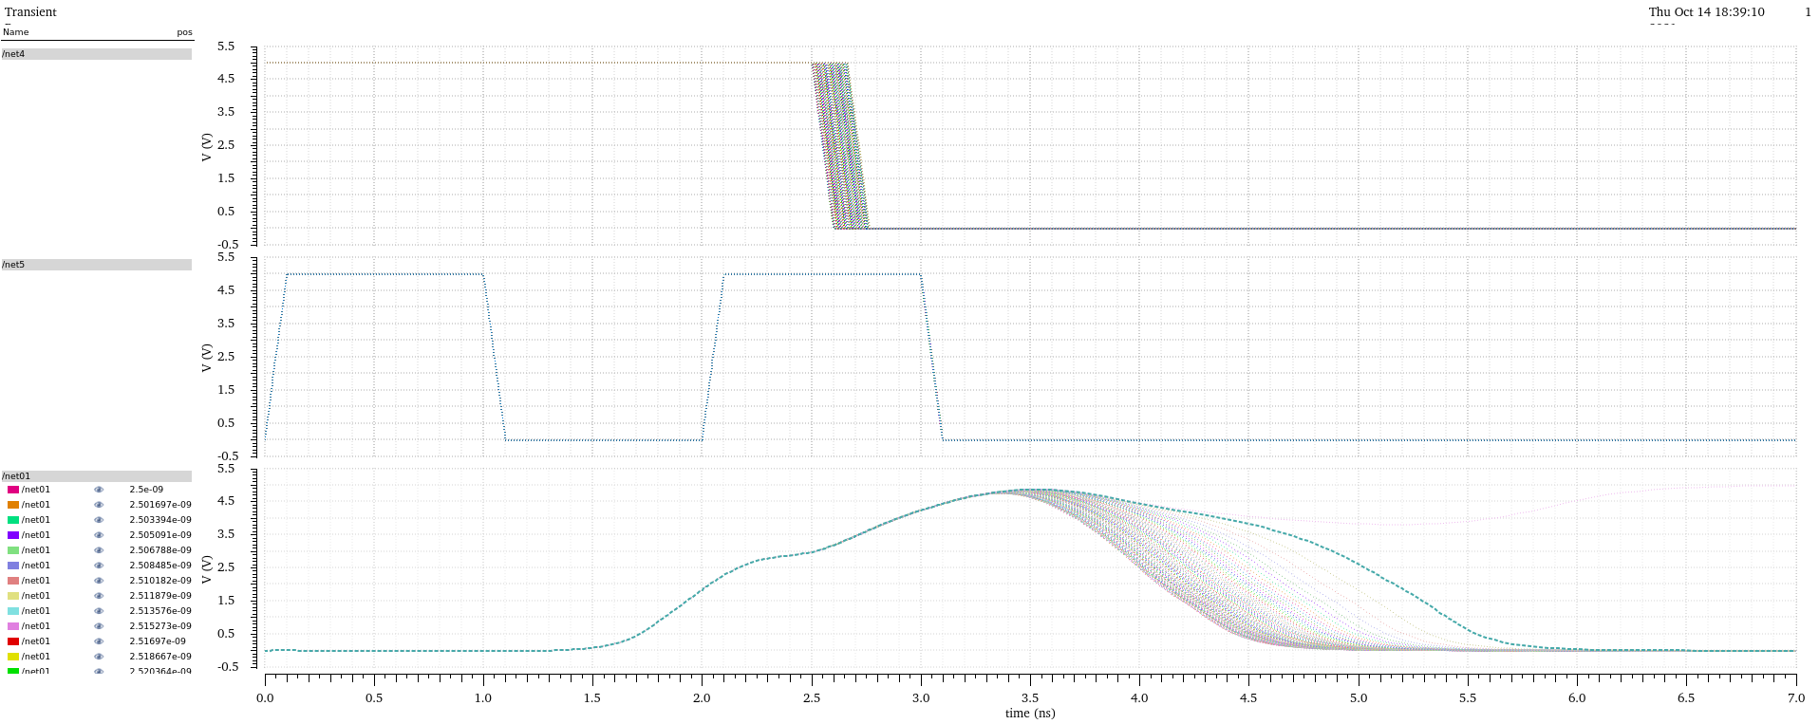
Figure 17: Extracted Transmission Gate Flip Flop Fine Sweep Latching 0
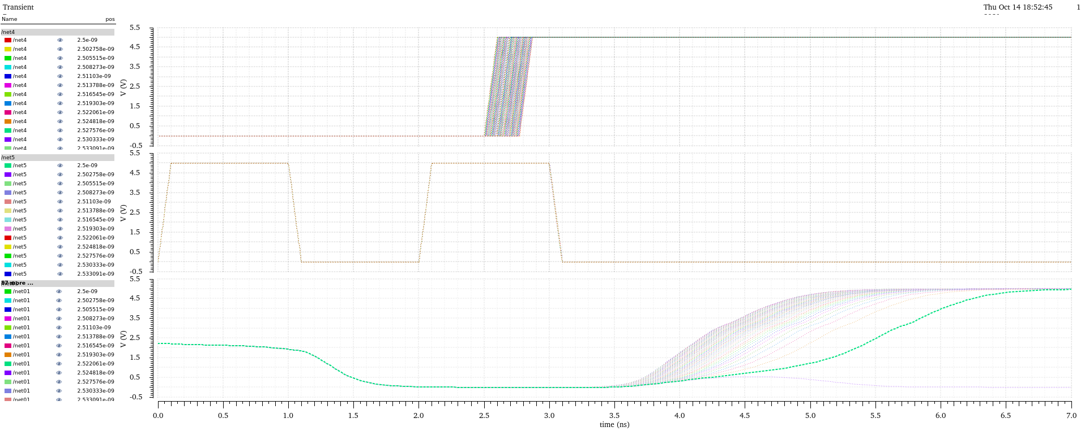
Figure 18: Extracted Transmission Gate Flip Flop Fine Sweep Latching 1
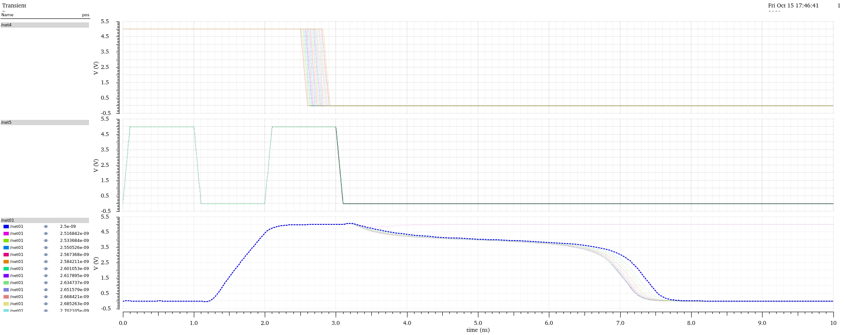
Figure 19: Schematic Transmission Gate Flip Flop Coarse Sweep Latching 0
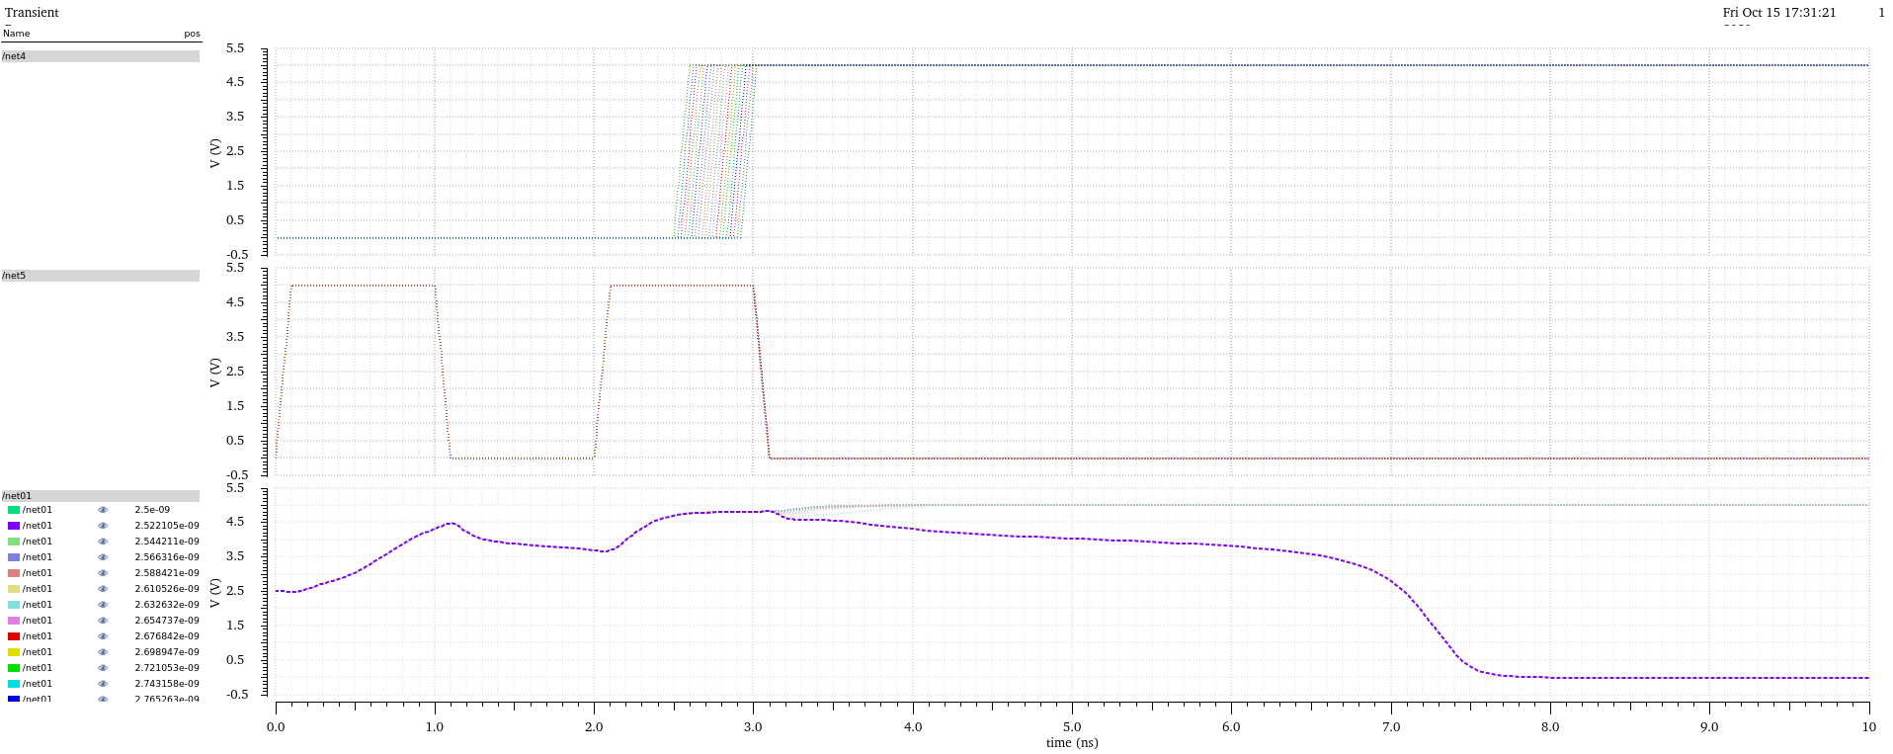
Figure 20: Schematic Transmission Gate Flip Flop Coarse Sweep Latching 1
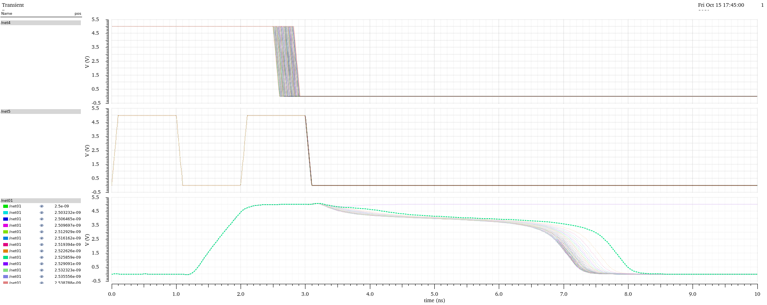
Figure 21: Schematic Transmission Gate Flip Flop Fine Sweep Latching 0
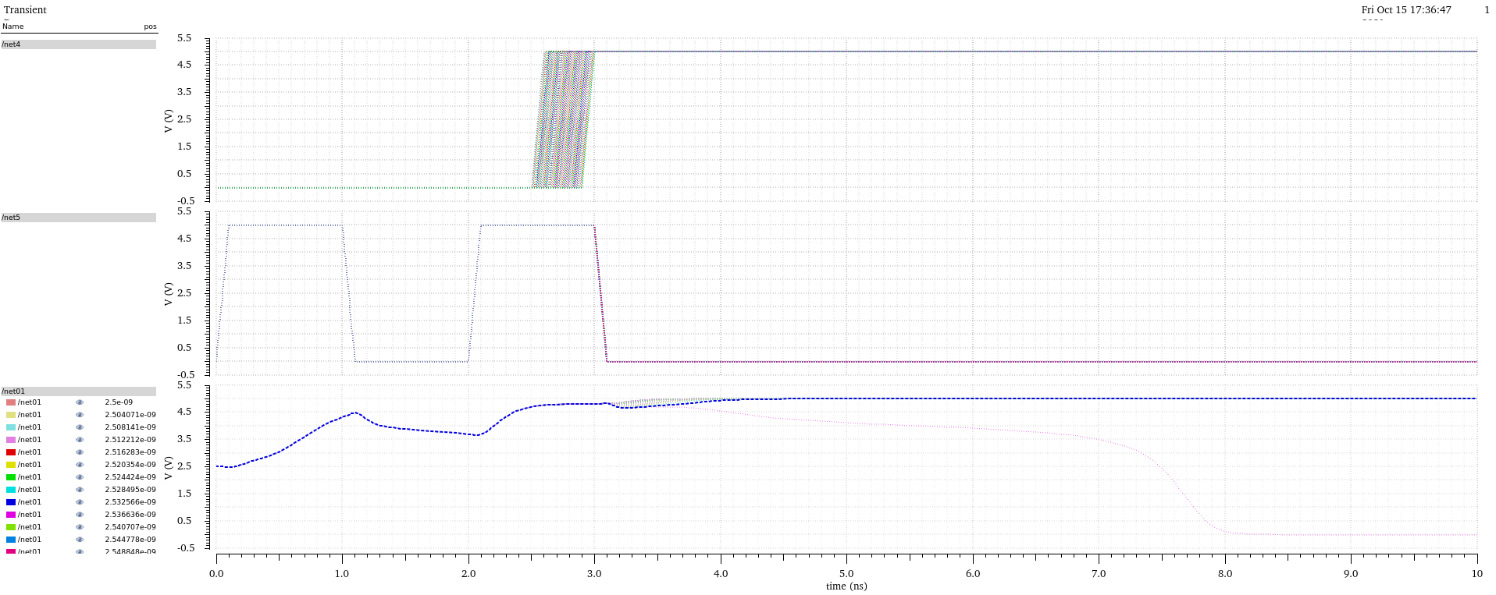
Figure 22: Schematic Transmission Gate Flip Flop Fine Sweep Latching 1

